13. Punt Kick

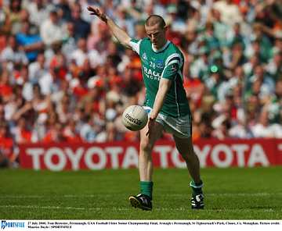

- Introduce
- Demonstrate
- Execute
- Attend

Release ball into the hand at kicking side

The Punt Kick is one of the most common foot passing techniques in Gaelic Football. It may also be used to kick for a score when approaching the goal straight on.

Step forward with non-kicking foot

Look out for:
- Lifting the head too early
- Dropping the ball with the opposite hand to kicking foot
- Toes not pointed

Kick ball with instep

Toes pointed, follow through
Pg. 23-28 FFD

Punt Kick

Practice the Technique


Pass and Follow
Each player Punt Kicks to the next player and continues to that line


Down the line
Players move forward and Punt Kick the ball to the next player and join the back of that line
Six Star Drill
Players Punt Kick to the player at the second marker on their right and joins that line

Develop the Skill


Empty the Circle
Players in the circle keep the circle clear by Punt Kicking any balls out of it.

Hit the Cones
Players Punt Kick the ball to hit the cones in the middle



